MASTERS DOCUMENTATION

Application : | NGERP
Workflow : | MASTERS
Workflow Item Name : | Tax Category

Description :

Tax Category Master is Used to Create Tax Category.

Workflow Process :

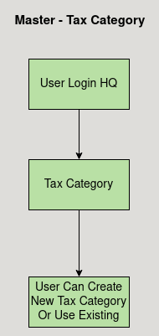

Business Rules :

- The Tax Category Master is used to create tax category.
- Tax Category can be only created in HQ.
- Tax Category should be Active to show in the tax category list.
- Tax Category Must be assigned to Tax Rate to calculate Tax.

